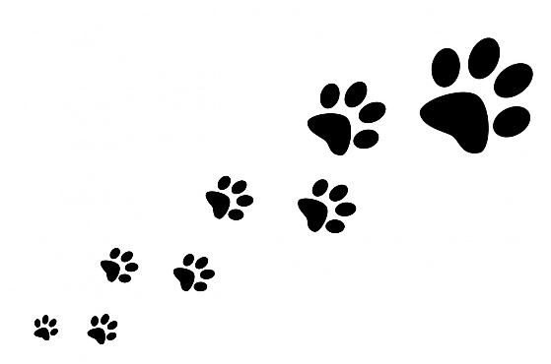

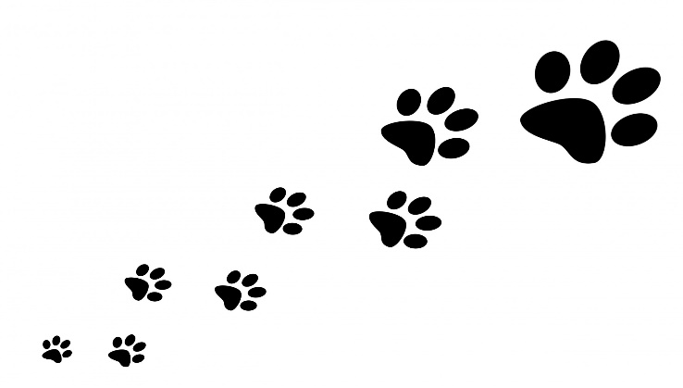Paws on Parade Dog Costume Contest

Registration Form

On the stage at Depot Park in Historic Downtown Russellville

**Saturday October 26, 2024**

**Registration 9:00 a.m. – 1 pm. (no late entries accepted)**

**Contest Begins promptly at 1:30 PM**

All dogs must be leashed and under control at all times.

Awards for Best Big Dog Costume, Best Lil Dog Costume, Most Creative, and Best in Show (Judges’ Choice)

Pup’s Name: ___________________________________________________

Pup’s Age: _________ Pup Size: _____Over 50 lbs _____Under 50 lbs

Pup’s Breed (we love mutts!): _____________________________________

Costume Description: ___________________________________________

Hooman’s Name: ______________________________________________

Hooman’s Phone Number: _______________________________________

I give my permission for my dog and their handler to be photographed during the Paws On Parade Costume Contest.

I understand photos may or may not appear in Fall Fest publicity.

**___________________________________________**

**Parent/Guardian (Human) Signature**

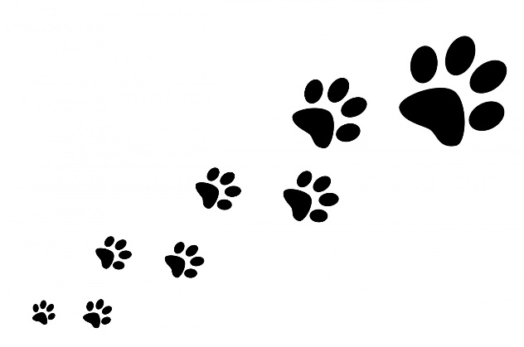 **Sponsored By:**

